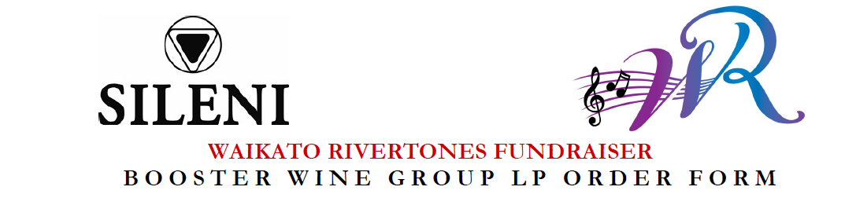

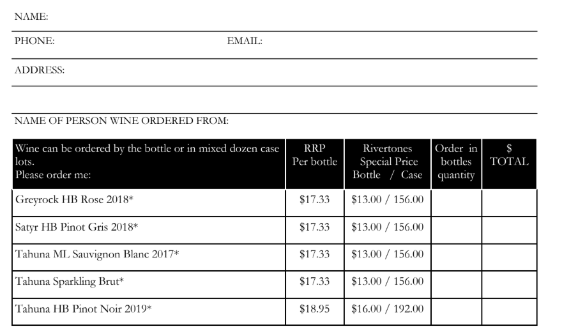
a
NAME:
PHONE:
EMAIL:

ADDRESS:

NAME OF PERSON WINE ORDERED FROM:

Offer is available from Monday October 14th 2019 until Friday 25th October 2019
The offer is available for personal consumption only. It is not to be on-sold and is not available to On and Off Premise licence holders
Complete the order form.
Order forms are available as a paper copy, as an editable word document available from your Waikato Rivertones contact, or you can download this from our website at www.waikatorivertones.com
Email order forms to Jackie Napier at orders@waikatorivertones.com
Make payment by direct deposit to Waikato Rivertones fundraising account #03-1556-0043051-00 Make sure you include your name and the word ‘Wines’ as the reference. This is our preferred payment option.
Payment can also be made by cash or cheque (Waikato Rivertones). Give your payment and order form to your Waikato Rivertones contact.
Your order will be processed after the fundraising closing date (25th October) & once your payment has been received and processed.
Phone No. for enquiries: Jackie 029 4998764 / 07 544 8866
Delivery will be in early November.

Offer available while stocks last. Booster Wine Group L.P. reserves the right to change vintage &/or brand of wine offered for a wine of equal quality and value dependant on stock levels.
$40.00 (incl GST) per case will be provided in sponsorship to the Waikato Rivertones to assist with fundraising for vocal education for women of all ages that enjoy singing.

I am over 18 Years of age (tick ) Yes * Signature: _________________ Date of Birth: ________
Signature acknowledges that I am 18 years of age or over.

For further information regarding Booster Wine Group LP fundraiser package please email: directsales@sileni.co.nz
Persons under the age of 18 years may not order or receive wine on behalf of anyone else.
All wine to be sold by persons 18 years of age and over only. Licence No 29/OFF/007/18

