Carols at the Lake
Sunday 17th December 2017, 5.00pm – 9.00pm
Hamilton Lake Stage

Thank you for agreeing to perform at this weekend’s Carols at the Lake event. We are looking forward to a wonderful night of family festive fun. Below is some information regarding location, timing and the event in general. If you have any questions or concerns please feel free to contact me on 021 775 626.
Location
The event is taking place on the stage at Hamilton Lake (below the water tower). The area can be accessed from either Ruakiwi Rd or within the lake domain.
There is some (very) limited parking available for those who are bringing in heavy equipment otherwise parking will need to be found on surrounding streets.
Sound Check
There will be a sound check for all performers (that are able to make it) at midday on Sunday. Please make sure that you bring with you (or email to me in advance) a copy of your set list to help our sound engineer.
If you are using backing tracks then USB is the preferred method (although Scott is very flexible :)
Programme
Time | Performer/Contractor | Description
12:00 – 1.15pm | Sound check | Stage
5:00-6:00 | Bubble Man | Interactive Children’s show
5:15-6:45 | Christmas elves | Street Theatre
5:30-6:30 | Victorian quoits | Elves and games
5:45-6:05 | TBC
6:05-6:10 | MC
6:10-6:30 | Impact Dancers | Dance Performance
6:30-6:35 | MC | Tech changeover
6:45-7:00 | Bryan Bevege & Chris Maydon | Duo - Christmas ballads
7:00-7:25 | Coopers Run | Duo
7:25-7:30 | MC | Tech changeover
7:30-8:00 | Waikato Rivertones
20:00 | MC | Tech changeover
20:00-20:15 | Hamilton Gospel Choir
 | MC
20:15-20:45 | Hamilton Gospel Choir & Salvation Army Band
20:45-20:48 | MC | Invite performers back to stage
20:48 – 21:00 | Salvation Army Band and Choir  All other performers
21:00 | MC
21:05 | Playout/house music

Please note if you are able to stay on following your performance we would love to have everyone back on to the stage for a final sing out at the end of the evening – the MC will let you know when

Health and Safety
A few things to be aware of :-
- Please be aware of the weather conditions and keep well hydrated, fed and sun screened and/or warm and dry
- The area does have a sand fly population so insect repellent is recommended
- The stage floor is quite uneven so please watch you step
- Use handrail provided for the stage stairs and let our team know if you are having any problems
- There is a dressing room space behind the stage – we will have a volunteer situated there throughout the evening so you are able to leave water bottles, hats, keys etc there safely
- As it will be dark when the event finishes we would recommend that people make their way back to their vehicles in groups – or let one of our volunteers know and we will make sure someone walks with you
- Bring a torch or similar to make the walk out a little easier

Cancellation
Should the dreaded thing happen and the weather makes it necessary for us to cancel, I will be in touch with the key contact people as early as possible. Cancellation would only be necessary if the rain was heavy and persistent and meant that continuing was dangerous.

Site Plan

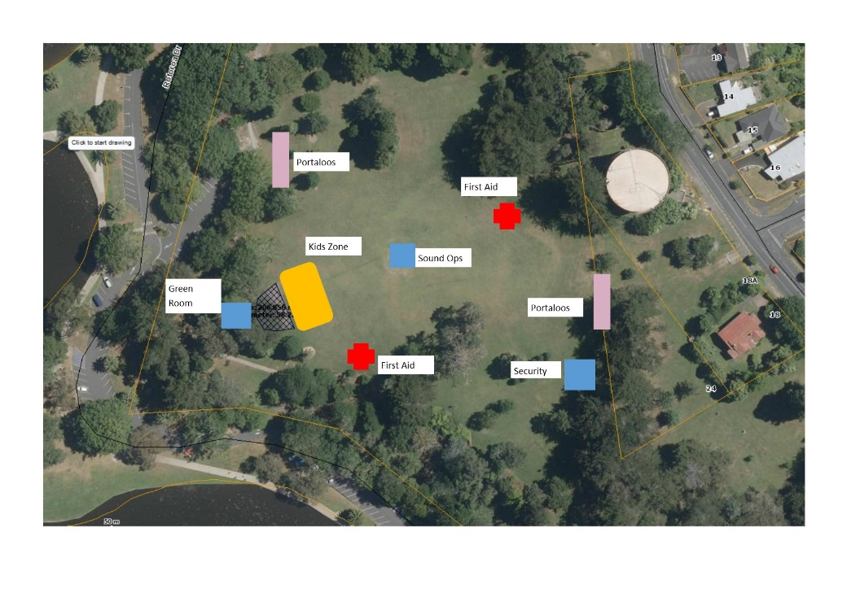

Lastly, thank you all.
Wishing you a very Merry Christmas and safe and happy holidays
Tracey Wood

